Automation creation Document.

Installation of UIPath.

First we need to create login to [www.cloud.uipath.com](http://www.cloud.uipath.com) in that we need to create an account with either Gmail or outlook.

After creating the account we have to download the UiPath studio from the orchestrator. Then this uipath tool will be opened.

Creation of AQC.

Create a blank process shown in the below screenshot

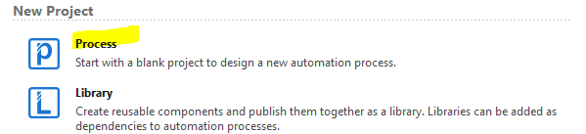

After clicking on the process we have to give the required name for the process.

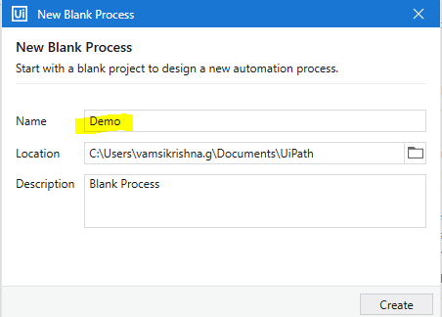

After creating the process main will be popping up we have to click on the main and have to start writing the code

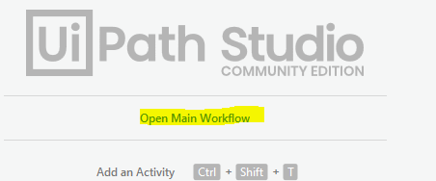

Initially we have to take the sequence in the main and in the main we have to take the state machine all our process will be running in the state machine.

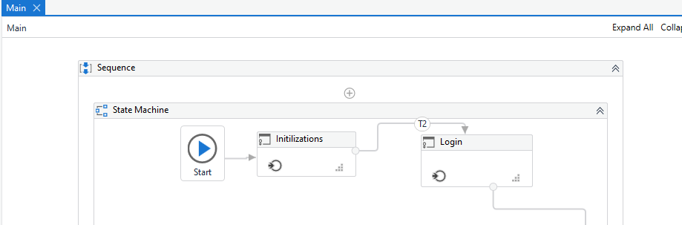

In the state machine we have write code in different states and with the help of transitions. In this AQC status we have different states like initialization, login, navigation to dashboard, search, ingest status check, Aqc status and sending the mail.

Initialization:

All the details are taken form excel files in which we will call the values by different arguments. Mentioned in screen shots

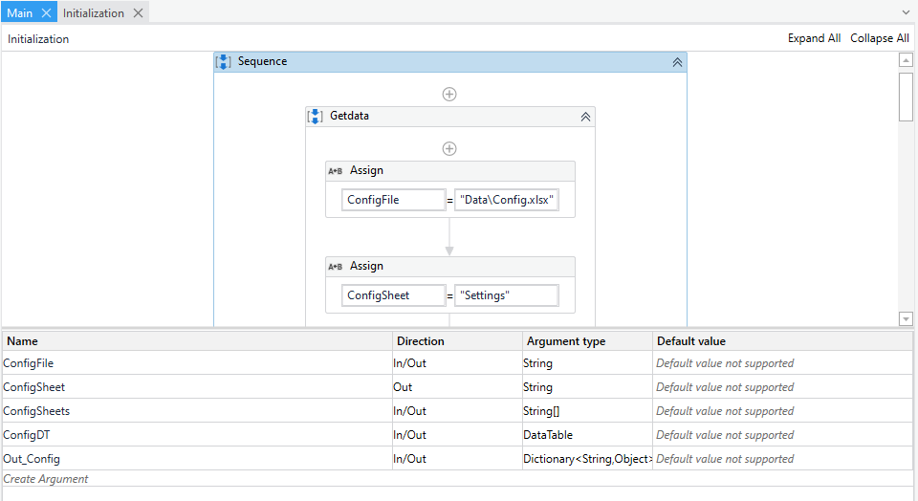

All the input and output functions will be called with this augments. We have the report part which we have the generic bot already created we have to give path in the augments.

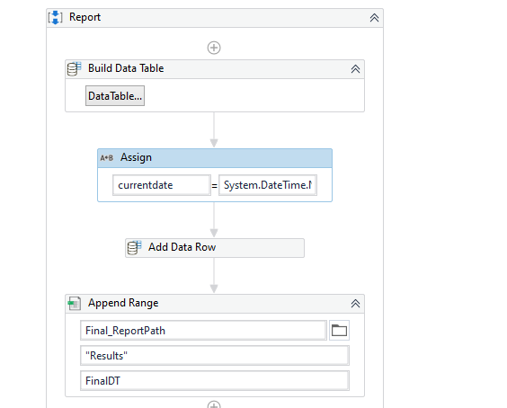

Login:

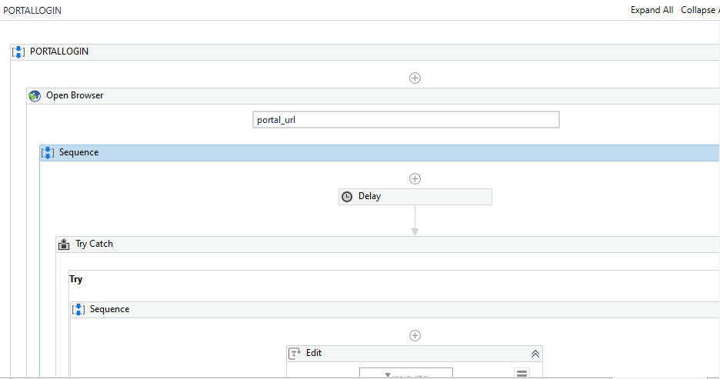

For portal url login we have browser activity in the uipath we have to take the actives and have to pass the value after that we have given the sequence for check the edit button in user credentials based on the edit our username and pass word will be entered and logged into the user.

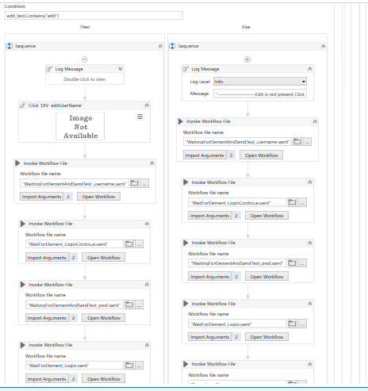

Navigation and Search:

After login I have taken the two different sequences for the navigation and search

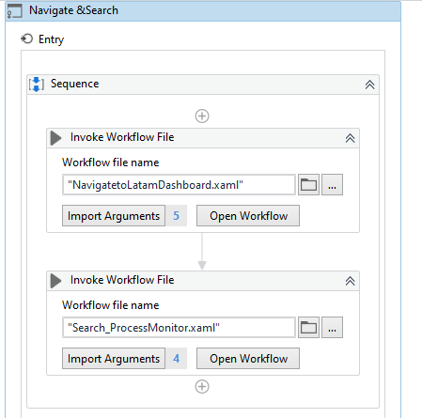

In this navigation sequence we have taken the all the menu actions in the different arguments mentioned below in the sequence. We have taken in arguments because whenever any changes happen in the code level from dev end only we need to change the path in the arguments.in this navigation we are checking the label of latam.

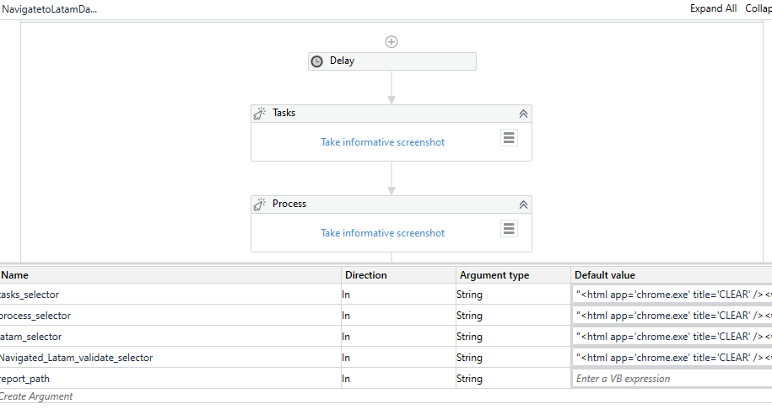

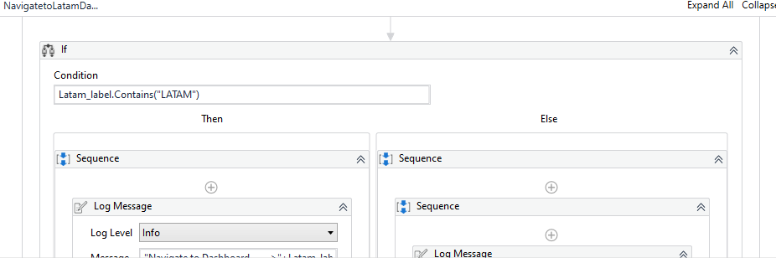

After this navigation we will be searching with the Title and chapter it should match the searched the title and chapter after the search.

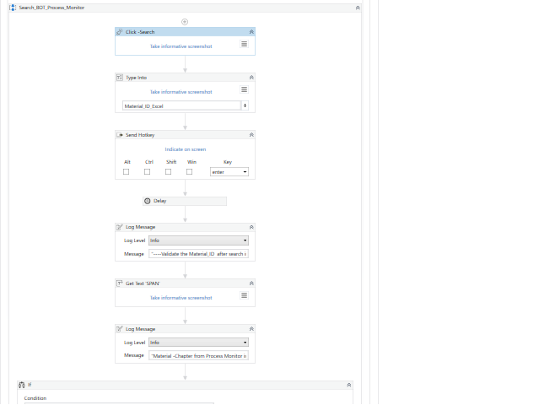

The condition please find the below screen shot.

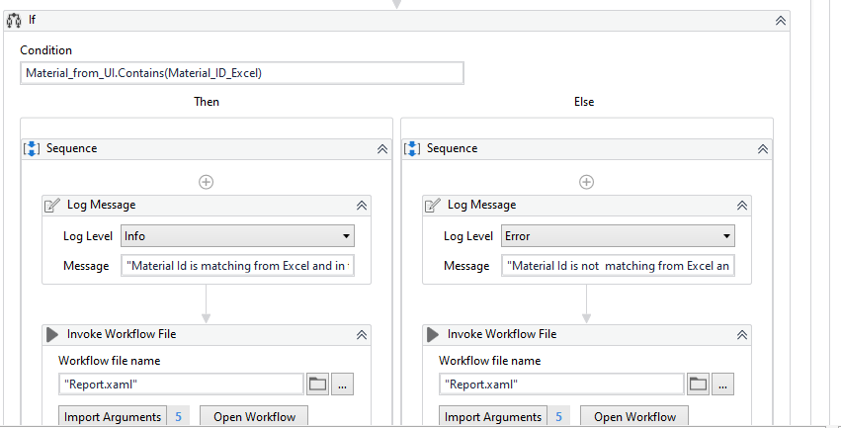

If the both material id is matched then only the work flow will be moved.

Ingest Status Check:

We have kept the check point like checking the ingest status before checking the AQC if the ingest status is failed it will not be moving to the next status.

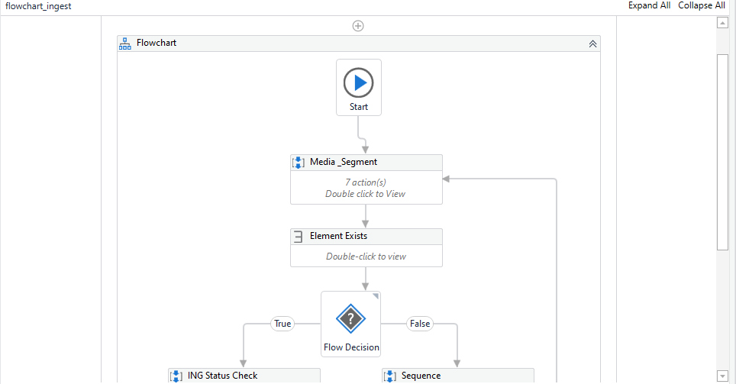

In the above mentioned screen shot we are taking the status by creating a variable “Found” which is Boolean if the status exist it will be moving to next node or if it is not found it will be closing the portal and send the message “ingest status fail” and close the portal. We used flow decision because to check the Boolean values and stored in the variable.

After the ingest status message it will move to the AQC.

AQC status check:

For this we have taken the new state and renamed to AQC status check. In the same way we checked the AQC status the mouse will be moving to the status and initially it will check the information .

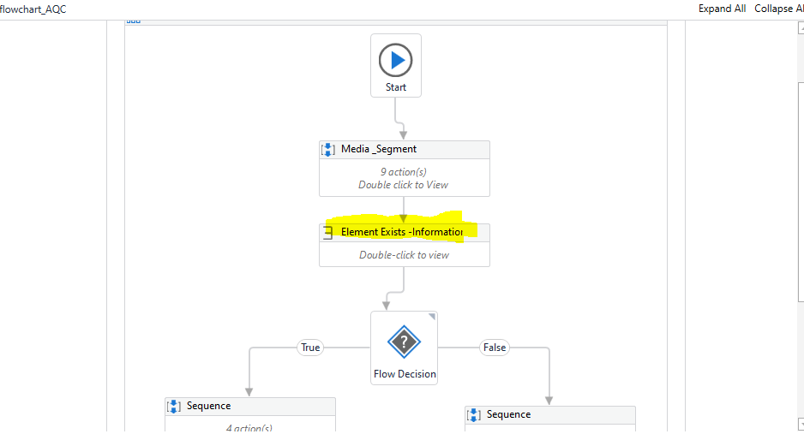

Based on the information status “pass” the bot will send the message “AQC passed initially” and logout the user and close the portal

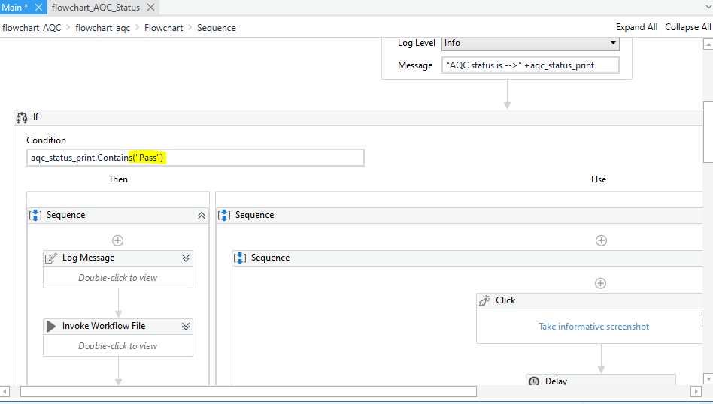

When the AQC status is fail then it will again click on the AQC status and perform “AQC override pass” from the dropdown and download the report. For checking this AQC override pass in the dropdown again we are using decision called “found1“

As the other variable.

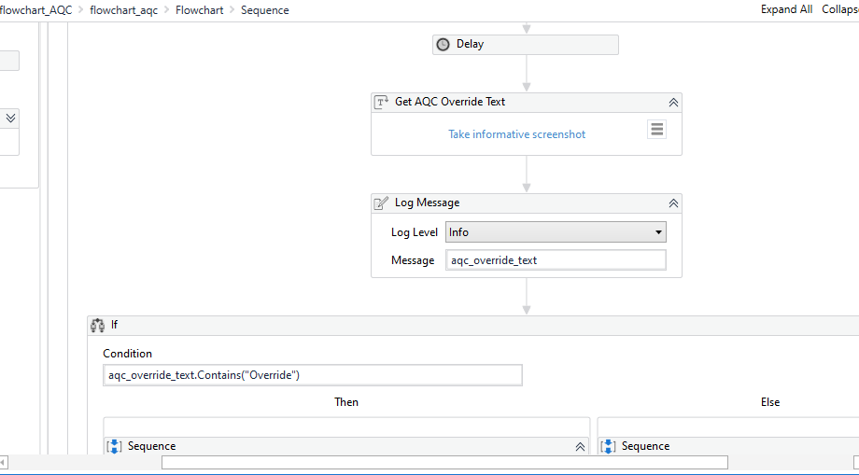

After performing the AQC task it will be downloading report. After downloading the report the user will be logged off and portal will be closed from the bot.



